**The Study of Customer Satisfaction inService**

**Quality Towards Kandawgyi Palace Hotel,**

**Yangon, Myanmar**

Miss Eaindrae Maung Maung1 , Dr. Vijit Supinit 2

MBA, Siam University, Thailand

**Abstract**

To sustain in the hotel industries especially for long lasting and have competitive advantage over others should have to find different alternatives to maintain customer satisfaction and to accomplish it hotel industries should focus on its key factors that enable them to increase the customer satisfaction and customer retention. This research paper identifies service quality, perceived value and customer expectation as vital factors affecting customer service. Quality of service and customer satisfaction are critical factors for success of any business (Gronoos, 1990; Parasuraman et al., 1988). As Valdani (2009) points out: enterprises exist because they have a customer to serve. The key to achieve sustainable advantage lies in delivering high quality service that results in satisfied customers (Shemwell et al, 1998). The main purpose of this study is to study the guest’s responses at kandwagyi palace hotel Yangon, Myanmar and the results of this study can provide the wide variety of different alternative to tackle the customer demands and needs. After completion of all data analysis the researcher found out that there is a strong relationship between dependent variables (Perceived value, service quality and customer expectation) and independent variables (customer satisfaction) and three hypotheses proved that there is a strong relationship and accepted the relevant relationship, data collected were correct and significant. In addition, the relationship between customer demands and expectation could also be conducted and use of different statistical method to analyze the test between service quality and customer satisfaction. This research work can also be applied to different sector as well such as manufacturing sector, marketing and aviation sector. *Keywords:* Service quality, perceived quality, customer expectation, customer satisfaction**.**

**1. INTRODUCTION**

The Kandawgyi Palace Hotel is located in the downtown of Yangon, Myanmar and has 119 rooms, all of which are equipped with a spa bath and a shower that targets local and tourist around the world by retaining the traditions of Myanmar architecture using local golden teak and modern conveniences blend with the beautiful environs of the lake, gardens and original old rainforest make our Hotel the preferred destination in Yangon, Myanmar for both discerning business travelers and tourists alike. Rooms are pleasantly designed with wooden floors and international facilities. At present, hotel visitors in Myanmar seem to have high standards and demands for excellent service. The hotels have increased their competition and now instead of having only a nice room to draw customers in, they offer -high quality staff. As an amenity as well. Guest satisfaction is the highest priority for owners and managers competing with hundreds of others, and personal service is at the top of the travelers& list of the most important things when considering a hotel to stay in (Wipoosattaya, 2001).

In order to achieve customer satisfaction, it is important to recognize and to anticipate customers' needs and to be able to satisfy them. Enterprises which are able to rapidly understand and satisfy customers' needs, make greater profits than those which fail to understand and satisfy them (Barsky & Nash, 2003). Since the cost of attracting new customers is higher than the cost of retaining the existing ones, in order to be successful managers must concentrate on retaining existing customers implementing effective policies of customer satisfaction and loyalty. This is especially true in the hotel industry. Customer requirements for quality products and service in the tourism industry have become increasingly evident to professionals (Lam & Zhang, 1999; Yen & Su, 2004). Guest relationships are a strategic asset of the organization (Gruen et al., 2000) and customer satisfaction is the starting point to define business objectives. In this context, positive relationships can create customer’s higher commitment and increase their return rate. Long-term and reciprocally advantageous relationships between customers and the hotel is becoming progressively important because of the highly positive correlation between guests' overall satisfaction levels and www.ccsenet.org/ijms International Journal of Marketing Studies Vol. 2, No. 2; November 2010 4 ISSN 1918-719X E-ISSN 1918-7203 the probability of their return to the same hotel (Choi & Chu, 2001). Hotels are increasing their investments to improve service quality and the perceived value for guests so as to achieve better customer satisfaction and loyalty, thus resulting in better relationships with each customer (Jones et al., 2007). Relationship quality has a remarkable positive effect on hotel guests’ behavior: it creates positive word of mouth (WOM) and increments repeated guest rates (Kim et al., 2001).

This research studies the customer satisfaction and loyalty toward Kandawgyi Palace hotel in Yangon, Myanmar in view of an interesting case study that can use the result obtained for a service development and improvement in the future.

**2. LITERATURE REVIEW AND CONCEPTUAL FRAMEWORK**

**CONCEPTUAL FRAMEWORK:**

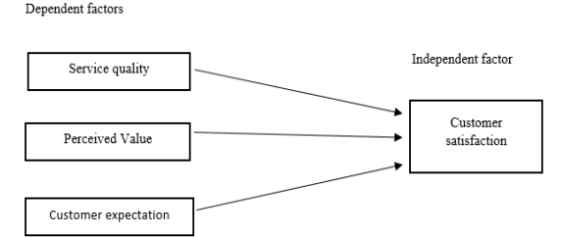

**Hypothesis mentioned:**

H1: Service quality has a direct impact on customer satisfaction in hotel industry

H2: Perceived value has a direct relationship with customer satisfaction

H3: Customer Expectations has a direct influence on customer satisfaction in hotel Industry.

The research problem in this paper was how Kandawgyi Palace Hotel to survive in the market to attract customers over its competitors such as in Yangon such as Sedona Hotel Yangon, Chatrium Hotel Royal Lake Yangon, Savoy Hotel, PARKROYAL Yangon, The Stand Yangon, and Anantara (being constructed) are strongly competing with five-star hotel chains. This paper also outlined how Kandawgyi Palace hotel can retain its customer over other by influencing the three major factors such as Service quality, Perceived value and customer expectation.

Furthermore, this study had to assessed the customer satisfaction towards service quality at Kandawgyi Palace hotel because it would be beneficial for the hotel industry to learn different innovative ways to attract and retain their customers and also by providing important training platforms to their staffs so that they perform better which can cause the increment in customer visits.

**LITERATURE REVIEW:**

**Customer satisfaction**

Customer satisfaction is a business philosophy which tends to the creation of value for customers, anticipating and managing their expectations, and demonstrating ability and responsibility to satisfy their needs. Qualities of service and customer satisfaction are critical factors for success of any business (Gronoos, 1990; Parasuramanetal., 1988). As Valdani(2009) points out: enterprises exist because they have a customer to serve. The key to achieve sustainable advantage lies in delivering high quality service that results in satisfied customers (Shemwellet al, 1998).

Kotler (1999) was the pioneer of generating the term customer satisfaction in business and marketing. Researchers have introduced numerous explanations for customer satisfaction. Vanacore and Etro (2002) proposed customer satisfaction as the general assessment, which is done by customers about specific product or service at a certain time. A particular instance of theories that has a significant influence on customer satisfaction is the Expectancy Disconfirmation Theory that is discussed enormously in customer satisfaction literature. This theory illustrates the pros and cons about changeability based on the perception of purchasing a product or service before them bargain. Presence of service also could be justified based on satisfaction and dissatisfaction. Zeithaml and Bitner (2003) discussed that dissatisfaction appears when the customers experience significant difference between their expectations and the quality of services that they receive. Vanacore and Erto (2002) believe that the main precursor of customer satisfaction includes expectations, perceived quality, and disconfirmation. American Customer Satisfaction Index (ACSI) is a sample of appropriate customer satisfaction model. This specific model consists factors of variables of customer loyalty, perceived value, perceived service quality, customer expectations and customer complaints.

**Service quality:**

Service quality is the result of the comparison that customers make between their expectations about a service and their perception of the way the service has been performed (Gronroos, 1984; Parasuraman et al., 1985, 1988). A number of experts define service quality differently. Parasuraman et al. (1985) define it as the differences between customers, expectation of services and their perceived service. If the expectation is greater than the service performance, perceived quality is less than satisfactory and hence, customer dissatisfaction occurs. Lewis and Mitchell (1990), Dotchin and Oakland (1994), and Asubonteng et al. (1996) define service quality as the extent to which a service meets customers, need and expectation.

**The SERVQUAL approach:**

The SERVQUAL approach has been applied in service and retailing organizations (Parasuraman et al., 1988; Parasuraman et al., 1991). Service quality is a function of repurchase customers, expectation, perceived process quality, and perceived output quality. Parasuraman et al. (1988) define service quality as the gap between customers, expectation of service and their perception of the service experience.

**Perceived value:**

The perceived value has been examined by various authors as factor which has a great influence on the decisions making process of customers. Reviewed literature suggests that the perceived value of customer play a significant role in determining customer satisfaction, decision making and purchase behaviors (Kuo, Wu and Deng, 2009; Reid, Pullins, and Plank, 2002). In addition, the reviewed study on perceived value indicates that perceived value is considered as a significant element in affecting consumers’ consumption and decision making behaviour (Kuo, Wu and Deng, 2009; Eggert & Ulaga, 2002; Reid, Pullins, and Plank, 2002; Cronin, Brady, & Hult, 2000). Among these notions, Customer perceived value can be described as the evaluation of comparing the perception of typical perceived value and real outcome of purchase experience.

**Customer expectation:**

Customer expectations are beliefs of an individual about service performance before they receive the actual service delivery (Zeithaml et al., 2006, P. 81). In evaluating service quality, it is a comparison of customer’s expectation with the actual performance of service, and the different between customer expectations and perceptions of service is the “customer gap” in which a firm needs to close that gap (Bateson, 1995, P. 559; Zeithaml et al., 2006, P. 33). Moreover, the expectations and perceptions of customers are dynamic and constantly change over the time, so a firm must be continuously examining any changes to make an improvement quickly (Palmer & Cole, 1995, P.152; Zeithaml et al., 2006, P.33).

Davidow and Uttal (1989) proposed that customers, expectation is formed by many uncontrollable factors which include previous experience with other companies, and their advertising, customers, psychological condition at the time of service delivery, customer background and values and the images of the purchased product.

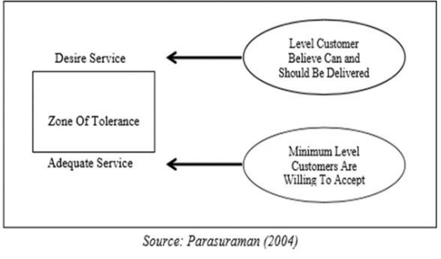

**Zone of tolerance of service expectation**

**Disconfirmation theory*:***

Disconfirmation theory was declared that satisfaction is mainly defined by the gap between perceived performance, expectations and desires which is a promising approach to explain satisfaction. This theory was proposed that satisfaction is affected by the intensity (or size) and direction (positive or negative) of the gap (disconfirmation) between expectations and perceived performance (Figure 2)

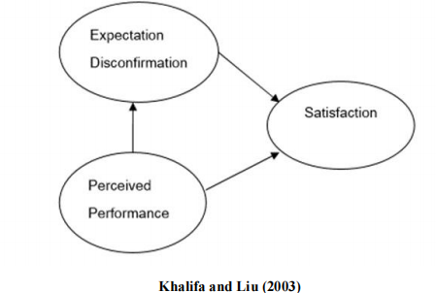

Expectation disconfirmation occurs in three forms:

1) Positive disconfirmation: occurs when perceived performance exceeds expectations.

2) Confirmation: occurs when perceived performance meets expectations.

3) Negative disconfirmation: occurs when perceived performance does not meet and is less than the expectations.

**3. METHODOLOGY**

The American Marketing Association defined marketing research as “the function with link the consumer, customer and public to marketer through information- information used to identify and define marketing opportunities and problems; generate, refine, and evaluate marketing actions; monitor marketing performance; and improve understanding of marketing as a process” (as cited in Parasuraman et al., 2004, P.8).

Research is a key tool for findings what customer want and how to satisfy their needs (Zikmund, 1997, P. 55) including understanding consumer expectations and perceptions of goods and services (Bateson, 1995, P.558: Zenithal et al., 2006, P.142) and linking consumer to marketer in making marketing decision (Burns & Bush, 2005, P.8).

**Research method:**

The research method used in this study was based on quantitative approach to gather primary data. There are many type of quantitative research; however, this study used the survey research via questionnaire to collect the data about attitudes of current customer at Kandawgyi Palace Hotel, Yangon. In order to obtain data for the calculation of explicit and implicit importance, as well as the level of customer satisfaction, this study used questionnaires as a tool to get responses from the subjects. The questionnaires were sent to their rooms upon arrivals, to rate the performance of the proposed quality attributes after there make use of the services in hotel, and also rating, in multiple item.

**Population and sampling:**

According to the purpose of this study, the target population of this research is customers who prior experience with Kandawgyi Palace Hotel, Yangon. Jackson (2008) suggested that a researcher can use a simple random sampling technique for selecting a sample that has an equal chance to be selected. It was estimated that Kandawgyi Palace Hotel, Yangon had about 250 persons of monthly customers. Therefore, this amount of customer was considered as population of the research.

In determining the sample size at Kandawgi Palace Hotel, there are several methods, however, selecting sample size in this research was based on the guidance of Naumann & Giel (1995) that present an appropriate sample size requirements regarding to population size shown in table (3.2.1.). The sample size for this study was 169

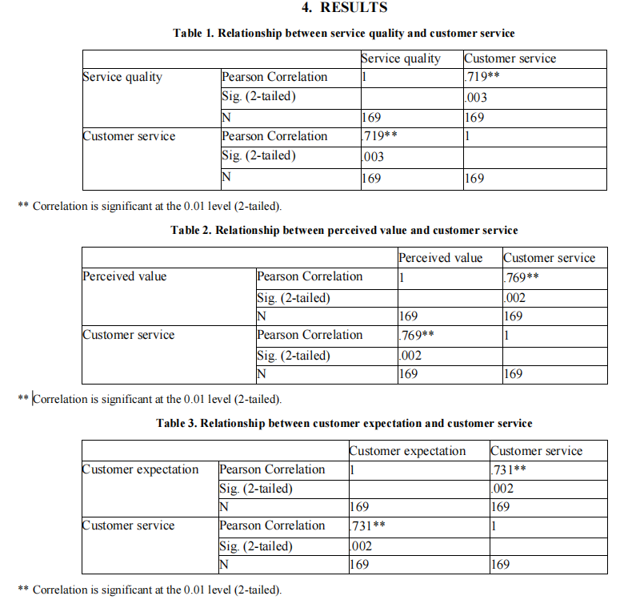

It’s confirmed that all the question is related in the same direction to determine same objectives of data analysis and according to the results arrived its concluded that with .819 of cronbach’s alpha reliability statistics accounted as “good” reliability test based on 25 questions.

**Relationship between service quality and customer service:**

From the results achieved in correlation table, it has been found out that the relationship between the service quality and customer service have strong relationship (.719**) as because correlation value is lower 0.03 and it explains that it’s below the level 0.05 margin error therefore the hypothesis H1 is accepted and there is a positive correlation between independent factors (service quality) and dependent factors (customer service).

**Relationship between perceived value and customer service:**

From the results achieved in correlation table, it has been found out that the relationship between the perceived value and customer service have strong relationship (.769**) as because correlation value is lower 0.02 and it explains that it’s below the level 0.05 margin error therefore the hypothesis H1 is accepted and there is a positive correlation between independent factors (perceived value) and dependent factors (customer service).

**Relationship between customer expectation and customer service:**

From the results achieved in correlation table, it has been found out that the relationship between the service quality and customer service have strong relationship (.731**) as because correlation value is lower 0.02 and it explains that it’s below the level 0.05 margin error therefore the hypothesis H1 is accepted and there is a positive correlation between independent factors (customer expectation) and dependent factors (customer service)

**5. CONCLUSIONS**

The study of customer satisfaction in service quality is a very important topic to be researched on as its provide the different variables to research for graduating students and enable them to know about their country economy and investment prospects. In order to go for detailed research students should know about how to achieve customer satisfaction, it is important to recognize and to anticipate customers' needs and to be able to satisfy them. Enterprises which are able to rapidly understand and satisfy customers' needs, make greater profits than those which fail to understand and satisfy them. As we know that the cost of attracting new customers is higher than the cost of retaining the existing ones, in order to be successful managers must concentrate on retaining existing customers implementing effective policies of customer satisfaction and loyalty. Therefore to compete with the competitors in hospitality sector and that can be achieved only by understanding different variables which provide high customer satisfaction in hotel industry to grow.

This research was mainly focused on customer satisfaction in service quality and emphasized on three main dependent variables to prove the independent variable.

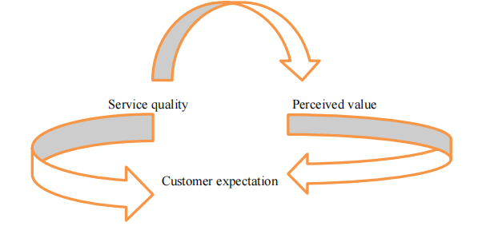

The aim of this independent study is to gather opinions of customers who experience in the service of Kandawgyi Palace Hotel and to achieve a better understanding of how the customer perceive and experience to the service provided. These are based on 6 dimensions of SERVQUAL tools including: Tangibles, Reliability, Responsiveness, Assurance, Empathy and customer satisfaction which are served as 6 criteria for making a judgment about quality of provided services by hotel guests.

**REFERENCES**

Anderson, E.W. & Fornell, C. (1994). *A Customer Satisfaction Research Prospectus in Service Quality: New Directions in Theory and Practice, Thousand Oaks, CA*. Sage Publications, Inc., 241-268.

Barsky, J. (1992). Customer Satisfaction in the Hotel Industry: *Measurement and Meaning. Cornell H.R.A., 7,* 20- 41.

Bitner, M.J., Booms, B.H. & Tetreault, S. (1990). The Service Encounter: Diagnosing Favorable and Unfavorable Incidents*. Journal of Marketing, 54*, 71-84.

Bitner, MJ. & Huber, A.R. (1993). Encounter Satisfaction Versus Overall Satisfaction Versus Quality, in The Service Quality Handbook, E.E. Scheuing & W.F. Christopher, eds. New York: *American Management Association*, 72-94.

Bolton, R.N. (1994). *Linking Customer Satisfaction to Loyalty and Revenues*. Working paper, GTE Laboratories Inc.

Boulding, W., Staelin, R., Kalra, A. & Zeithaml, V. (1993). A Dynamic Process Model of Service Quality: From Expectations to Behavioral Intentions*. Journal of Marketing Research, 30*, 7-27.

Boland D., Morrison, D., & O’Neil, S. “The Future of Airline CRM” IBM Institute for Business Value (2002).

Bowen, J.T. & Chen, S.L. (2001). The Relationship Between Customer Loyalty and Customer Satisfaction*. International Journal of Contemporary Hospitality Management, 13*, 213.

Buttle, Francis*. Customer Relationship Management*. Elsevier: n.p., 2004.

Greenberg, Paul. *CRM at the speed of light. Osborne*, U.S.A.: n.p., 2002. Giese, J.L. & Cote, J. A. (2000). Defining Customer Satisfaction. *Academy of Marketing Science Review. Reprieved July 18, 2007,* http://www.amsreview.org/articles/giese01-2000.pdf.

Gilbert, D. & Horsnell, S. (1998). Customer satisfaction measurement practice in United Kingdom hotels. *Journal of Hospitality & Tourism Research*, *22*(4), 450-464.

González, M. E. A., Comesana, L. R. & Brea, J. A. F. (2007). Assessing tourist behavioral intentions through perceived service quality and customer satisfaction. *Journal of Business Research, 60,* 153-160.

Grönroos, C. (1982). *Strategic Management and Marketing in the Service Sector*. Cambridge: Marketing Science Institute.

Grönroos, C. (1984). A service quality model and its marketing implications. *European Journal of Marketing*, *18*(4), 36-44.

Grönroos, C. (1990). *Service management and marketing: managing the moments of truth in service competition*. USA, Lexington Books.

Gundersen, M. G., Heide, M. & Olsson, U. H. (1996)

Kotler, P., *Marketing Management. Prentice Hall*, New jersey, U.S.A., 2003.

Kotorov, Radoslav P., *Ubiquitous organization: Organizational design for e-CRM*. Business Process Management 8(2002), 218-232.

Wirtz ,J., & Johnson ,R. (2003). “Singapore Airlines what it takes to sustain service excellence – a senior management perspective.” *Managing Service Quality 13*(1), 10-119.

Gustafsson A., Ekdahl, F., & Edvardsson ,B., (1999). “Customer focused service development in practice: A case study at Scandinavian Airlines System (SAS).” *International Journal of Service Industry Management, 10*(4), 344-358.

McQuitty ,S., Finn, A., & Wiley, J. B. (n.d.). *Systematically Varying Consumer Satisfaction and its Implication for Product choice.* Retrieved June 28, 2005, from http://www.findarticles.com/p/articles

Park J. W., Robertson., & Cheng L.W. (2004). The effect of airline service quality on passengers behavioral intentions: a Korean case study*. Journal of Air Transport Management 10,* 435-439.

Pieters, R., Koelemeijer, K., & Roest, H.,(1995) “Assimilation processes in service satisfaction formation*”. International Journal of Service Industry Management 9*(3) , 17-33.

Stefanou, C. J., Sarmaniotis, C., & Stafyla, A.(2003). CRM and customer-centric knowledge management: an empirical research. *Business Process Management Journal 9*(5), 617-634.

Haksever C. et al. *Service Management and Operations*, Prentice Hall, New jersey, U.S.A., 2002.

Wang Y., et al.(2004). An integrated framework for customer value and customer- relationship-management performance: a customer-based perspective from China*. Managing Service Quality 14*(2/3), 169-182. www.marketingteacher.com

Ekinci, Y. (2002). A Review of Theoretical Debates on the Measurement of Service Quality: Implications for Hospitality Research. *Journal of Hospitality & Tourism Research*, *26*(3), 199-216.

Faullant, R., Matzler, K. & Füller, J. (2008). The impact of satisfaction and image on loyalty: the case of Alpineski resorts. *Managing Service Quality*, *18*(2), 163-178.

Frochot, I. & Hughes, H. (2000). HISTOQUAL The development of a historic houses assessment scale. *Tourism Management, 21*(2), 157-167.

Fu, Y.Y. & Parks, S.C. (2001). The relationship between restaurant service quality and customer loyalty among the elderly. *Journal of Hospitality and Tourism Research*, *25*(3), 320-336.